Note 1201

Parameter name LBTEST (Char) | Short Name LBTESTCD (Char) | Category for Lab Test  LBCAT (Char) | Subcategory for Lab Test  LBSCAT (Char) | Original unit LBORRESU (Char) : Example | Standard unit LBSTRESU (Char)
ALBUMIN | ALB | BIOCHEMISTRY | METABOLISM | g/l | gD/l
ALKALINE PHOSPHATASE | ALP | BIOCHEMISTRY | LIVER FUNCTION | IU/l | IU/l
ALT/SGPT | ALT | BIOCHEMISTRY | LIVER FUNCTION | IU/l | IU/l
AST/SGOT | AST | BIOCHEMISTRY | LIVER FUNCTION | IU/l | IU/l
BLOOD UREA NITROGEN | BUN | BIOCHEMISTRY |  |  | MG/DL
CALCIUM | CA | BIOCHEMISTRY | ELECTROLYTES | mmol/l | mmol/l
CORRECTED CALCIUM (1) | CCA | BIOCHEMISTRY | ELECTROLYTES |  | Mg/DL
POTASSIUM | K | BIOCHEMISTRY | ELECTROLYTES | mmol/l | mmol/l
CREATININE | CREAT | BIOCHEMISTRY | RENAL FUNCTION |  | UMOL/L
CREATININE CLEARANCE CALCULATED (COCKROFT AND GAULT) (2) | CREACLCA | BIOCHEMISTRY | RENAL FUNCTION |  | ML/MIN
CREATININE CLEARANCE (2) | CREACL | BIOCHEMISTRY | RENAL FUNCTION |  | ml/min
CALCULATED CREATININE CLEARANCE (3) | CCRCL | BIOCHEMISTRY | RENAL FUNCTION |  | ml/min
GLUCOSE | GLU | BIOCHEMISTRY | METABOLISM |  | MMOL/L
HAPTOGLOBIN | HP | BIOCHEMISTRY |  |  | g/l
LDH | LDH | BIOCHEMISTRY |  |  | IU /L
MAGNESIUM | MG | BIOCHEMISTRY | ELECTROLYTES |  | MG/DL
SODIUM | NA | BIOCHEMISTRY | ELECTROLYTES | mmol/l | mmol/l
OROSOMUCOID | ORM1 | BIOCHEMISTRY |  |  | G/L
PHOSPHORUS | PHOS | BIOCHEMISTRY |  | mmol/l
TOTAL BILIRUBIN | TBILI | BIOCHEMISTRY | LIVER FUNCTION | umol/L, mg/dl, mg/l | mg/dl
TESTOSTERONE | TESTO | BIOCHEMISTRY
TOTAL PROTEINS | TPRO | BIOCHEMISTRY |  |  | G/DL
UREA | UREA | BIOCHEMISTRY |  |  | MMOL/L
HEMOGLOBIN | HB | HEMATOLOGY |  |  | g/l
INTERNATIONAL NORMALIZED RATIO | INR | HEMATOLOGY |  | RATIO | RATIO
NEUTROPHILS | NEU | HEMATOLOGY |  | 10E9/l | 10E9/l
PLATELET COUNT (THROMBOCYTE COUNT) | PLT | HEMATOLOGY |  |  | giga/l
SCHISTOCYTES (QUALITATIVE) | ? Attente réponse du data | HEMATOLOGY
WBC | WBC | HEMATOLOGY |  | 10E9/l | 10E9/l
PSA | PSA | SEROLOGY | TUMOR MARKER | MCG/L, NG/DL, NG/ML, UG/L | NG/ML
ALBUMIN (URINE) | ALBUR | URINALYSIS | 24H |  | MG/DL
ALPHA1 GLOBULIN | A1G | URINALYSIS | 24H |  | G :L
ALPHA2 GLOBULIN | A2G | URINALYSIS | 24H |  | G :L
BETA GLOBULIN | BG | URINALYSIS | 24H |  | G :L
CREATININE (URINE) | CREATUR | URINALYSIS | MORNING SPOT | g/l | umol/l
GAMMA GLOBULIN | GG | URINALYSIS | 24H |  | G/L
HEMOGLOBIN (QUALITATIVE) | HBQL | URINALYSIS
PROTEIN (URINE) | PROTUR | URINALYSIS | 24H |  | g/l
PROTEIN (URINE) | PROTUR | URINALYSIS | MORNING SPOT
PROTEIN (URINE) | PROTUR24 | URINALYSIS | 24H |  | G/24H
RED BLOOD CELLS (QUALITATIVE) | RBCQL | URINALYSIS | DIPSTICK
URINE PROTEIN CREATININE RATIO (4) | UPCR | URINALYSIS | MORNING SPOT |  | RATIO
URINARY VOLUME | UVOL | URINALYSIS |  |  | Ml
WHITE BLOOD CELLS (QUALITATIVE) | WBCQL | URINALYSIS | DIPSTICK

(1) Corrected calcium formula:

LBSTRESN(mg/dL) = [total calcium (mg/dL)] – [0.8*serum albumin (g/dL)-0.4]
LBTESTCD equal to "CCA" every time Calcium and Albumin are done the same time (i.e., same date, same page), a new line is created to determine the corrected calcium.

Since standard unit for calcium is mmol/L, it must be converted in mg/dL by multiplying the value expressed in mmol/L by 4
Since standard unit for albumin is g/L, it must be converted in g/dL by dividing the value expressed in g/L by 10
Then the formula can be applied and to obtain the value of corrected calcium in standard unit (mmol/L) the result must be divided by 4. on garde quoi au final en unite standard ? si c’est mg/dL, y a plus besoin de faire cette division

(2) Both from raw data, the first one calculated from creatinine value and the second one provided by investigator

(3) For all subjects, the creatinine clearance is recalculated
At each measurement of creatinine, age of the patient is recalculated as (date of creatinine value – date of birth)/365.25
Depending in the corresponding age, one of the two following formula is applied for creatinine clearance:

- this parameter is calculated in ml/min from the serum creatinine concentration using the Cockroft and Gault formula for subjects < 65 years:

LBSTRENI=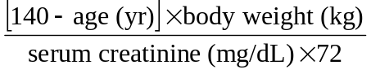,

where value of weight is the value measured: for baseline, at baseline and for each cycle.
If the weight is missing, the last non-missing weight is used.

Since the standard unit of creatinine is umol/L, it must be first converted to mg/dL by dividing the value by 88.4, which corresponds to apply following formula:

LBSTRENI=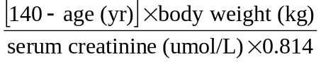,

For subject >= 65 years an abbreviated modification of Diet Renal Disease formula (aMDRD) is used:

LBSTRENI=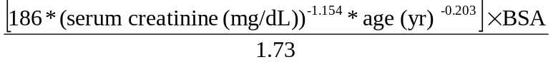,
Since the standard unit of creatinine is umol/L, it must be first converted to mg/dL by dividing the value by 88.4, which corresponds to apply following formula:

LBSTRENI=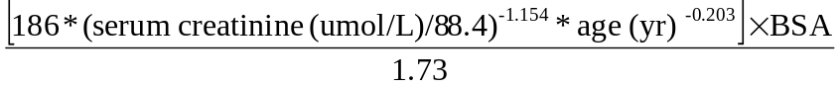,

For African descent (RACE=BLACK):

LBSTRENI=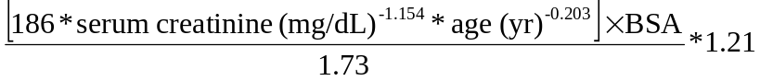,
Since the standard unit of creatinine is umol/L, it must be first converted to mg/dL by dividing the value by 88.4, which corresponds to apply following formula:
LBSTRENI=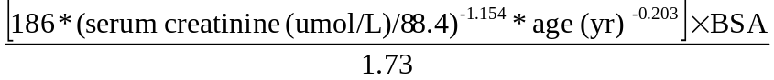*1.21

- Dedicated records are created in the dataset with all the variables regarding original value (LBORRES, LBORRESU, LBORNRLO, and LBORNRHI) as well as the following variables LBSTNRLO, LBSTNRHI, LBNRIND, and LBCONV, left empty. Only the Identifier Variables, the Topic Variables, the following Qualifier Variables LBTEST, LBCAT, LBSCAT, LBSTRESC, LBSTRESN, LBSTRESU, LBDIGIT, the Selection/Analysis Variables as well as the Timing Variables can be filled in. The Timing Variables correspond to those of the assessment of the serum creatinine concentration used in the formula. We kept weight and bsa for which date from VS <= date from LB except for visit=SCREENING. If we have no date from VS equals or prior the date from LB, we used the date from VS at SCREENING.

(4) For all subjects, the Urine protein to creatinine ratio is calculated.
Every time Urinalysis Spot protein and Urinalysis Spot Creatinine are done the same time (i.e., same date, same page; a new record is created with the formula:
UPCR=protein (g/dL)/ [creatinine (umol/l) /88400]

Note 1202
The determination of Reference Range indicator depends of Lower Limit of Normal (LLN) and Upper Limit of Normal (ULN).

LOW : LBSTRESN < LBSTNRLO
Else HIGH if: LBSTRESN > LBSTNRHI
Else NORMAL if: LBSTNRLO <= LBSTRESN <= LBSTNRHI

Note 1203
The determination of Reference Range indicator Imputed depends of Lower Limit of Normal (LLN) and Upper Limit of Normal (ULN).

LOW : LBSTRENI < LBSTNRLO
Else HIGH if: LBSTRENI > LBSTNRHI
Else NORMAL if: LBSTNRLO <= LBSTRENI <= LBSTNRHI

Note 1204

Toxicity is derived for the following parameters:
- Hematology parameters (LBCAT = HAEMATOLOGY) : Neutrophils (lbtestcd=NEU), Hemoglobin (HB), Platelets (PLT), White Blood Cells (WBC)
- Biochemistry (LBCAT = BIOCHEMISTRY) : Albumin (ALB), Alkaline phosphatase (ALP), Asat (AST), Alat (ALT), Total Bilirubin (TBILI), Creatinine (CREAT), Phosphorus (PHOS), Sodium (NA), Potassium (K), Magnesium (MG), Glucose (GLU), Corrected Calcium (CCA)
- Urinalysis -(LBCAT = URINALYSIS)
- LBELTM =MORNING: Protein (LBTESTCD=PROTUR)
- 24Hour (LBELTM = 24H): Protein (LBTESTCD=PROTUR)
- Urinalysis - Dipstick (LBMETHOD = DIPSTICK): Hematuria (RBCQL)

Note 1205

LBBLFL:

- For all test except PSA and Testosterone
Last non-missing value prior to first drug intake (included) for treated patients, otherwise prior to randomization (including the day of randomization).
In case of multiple non-missing values in the same day,
- For haematology, the lowest value is taken
- Otherwise, for biochemistry or urinalysis, it is the highest value

- For PSA
Last non-missing value prior to first drug intake (included) if (date of first IV - date of randomization) <= 3; last non missing value prior to randomization (including the day of randomization) but within 21 days before randomization otherwise.

- For Testosterone
Last non-missing value prior to randomization (including the day of randomization), or last non-missing value prior to first drug intake if no value is available before randomization

Note 1206

Visit Number (VISITNUM) | Visit Name (VISIT)
0 | SCREENING
1 | CYCLE 1
2 | CYCLE 2
3 | CYCLE 3
4 | CYCLE 4
5 | CYCLE 5
6 | CYCLE 6
7 | CYCLE 7
8 | CYCLE 8
9 | CYCLE 9
10 | CYCLE 10
11 | CYCLE 11
12 | CYCLE 12
13 | CYCLE 13
14 | CYCLE 14
15 | CYCLE 15
16 | CYCLE 16
17 | CYCLE 17
18 | CYCLE 18
19 | CYCLE 19
20 | CYCLE 20
21 | CYCLE 21
22 | CYCLE 22
23 | CYCLE 23
24 | CYCLE 24
25 | CYCLE 25
XX | CYCLEXX
80 | END OF TREATMENT
81 | FOLLOW-UP 1
82 | FOLLOW-UP 2
83 | FOLLOW-UP 3
84 | FOLLOW-UP 4
85 | FOLLOW-UP 5
86 | FOLLOW-UP 6
87 | FOLLOW-UP 7
….XX | FOLLOW-UP XX
99 | UNSCHEDULED

